


Empathy Map

Date | 02 July 2026
Team ID | SWTID-2026-9778
Project Name | Credit Card Approval Prediction
Maximum Marks | 4 Marks

Empathy Map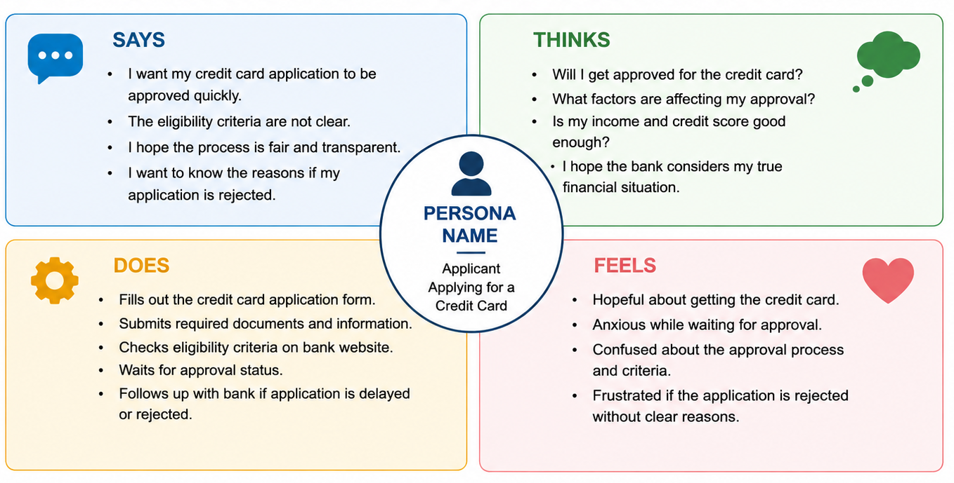
PERSONA NAME
(Role / User Type)
•
•
•
THINKS
•
•
•
SAYS
FEELS
•
•
•
DOES
•
•
•

